ETTIE ATHIRA BT HADLIN

Bachelor (Hons) of Electronic Engineering (Wireless Communication)

PERSONAL INFORMATION  NRIC : 910930-14-6456  Marital Status : Single  Nationality : Malaysian  Health : Excellence | 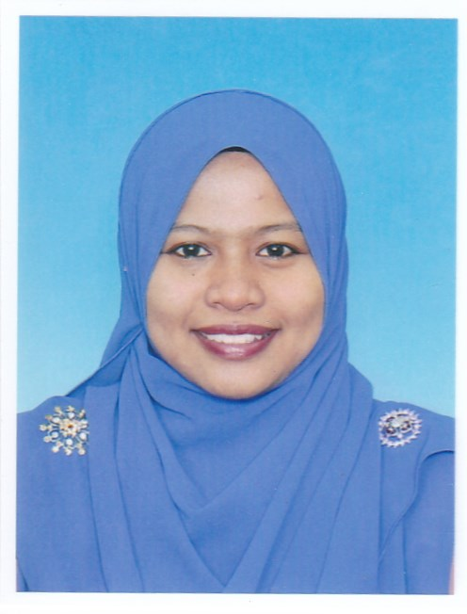  CONTACT DETAILS  Mobile : 012-3375372/ 011-14799918  Email : gettie91@gmail.com  Address : No 3 Jalan Inai 6B, Bukit Beruntung,  48300, Rawang, Selangor.

CAREER OBJECTIVES

I am looking forward with chances to develop my skills further. The first job determined my career path, I am interested to learn new things and tackle any new challenge.

EDUCATION

2011 - 2015 | Universiti Teknikal Malaysia Melaka(UTeM)  Ayer Keroh, Melaka  - Bachelor Degree of Electronic Engineering (Wireless Communication)  - CGPA – 2.93/4.00
2009 - 2011 | Kolej Matrikulasi Pulau Pinang(KMPP)  Seberang Perai, Pulau Pinang.  - Physical Science with CGPA 2.57/4.00
2004 - 2008 | Sekolah Menengah Kebangsaan Taman Bunga Raya  Bukit Beruntung, Selangor  - Sijil Pelajaran Malaysia  - Science Stream – 3A, 3B, 3C, 1D

EXPERIENCE AND PROJECT

Final Year Project Title | An Analysis of Vivaldi RCS Antenna at 6ghz for satellite communication
Objective/Functionality | - Main objective of this project is to design the Vivaldi RCS antenna at 6Ghz, choose the suitable method to develop the antenna and analyze the performance of the design antenna.  - Work with CST software to design the Vivaldi RCS antenna to working at 6GHZ and i took about 3 months to master on that software.  - The designated antenna is a special scatter and it is difficult to balance the characteristics of low RCS and good radiation performance simultaneously.  - Usually, RCS reduction will increase the complexity of the antenna system or degrade the radiation performance of the antenna

Company Name | Fuji Seats (Malaysia) Sdn Bhd
Date | Jun 2014 – August 2014
Position | Trainee (Plant Engineering)
Job Scope | - Prepare Hazard Identification, Risk Assessment & Risk Control (HIRARC) form for all working point  - Prepare report for all of the OSH activities for audit award JKKP Selangor.  - Assist the OSH commitee conduct the PPE inspection  - Involve in OSH metting and JKKP Audit award  - Prepare schedule fencing installation for new factory

Company Name | Telekom Malaysia
Date | Jun 2016 – Present
Position | Job Trainee (Global & Wholesale; Bussiness Development)
Job Scope | - Job training under department Global & Wholesale (division:product infrastructure)  - Was assign to complete the inventory of global cable networking.  - Assisting in IP Infra Implementation

CAPABILITIES

- As a leadership charisma that being build up since in the school, no problem to be a group player and work will people in all level
- Manage to work under pressure to meet the dateline
- Fast learner and always willing to learn new thing

SKILLS

Language skills | Bahasa Malaysia | English
Speaking
Writing

computer skills
Microsoft Word
Mirosoft Power Point
Microsoft Excel
Microsoft Visio

Engineering tools / pogramming laguage
Computer Simulation Technology (CST)
Advance Design Simulation (ADS)
C (intermediate)
MatLab (intermediate)

EXTRACURRICULAR ACTIVITIES

2011 - 2015 | Universiti Teknikal Malaysia Melaka(UTeM)  - Persatuan Silat Cekak Malaysia member (2013)
2009 - 2011 | Kolej Matrikulasi Pulau Pinang(KMPP)  - Vice President for Student Resedential College(2009)
2004 - 2008 | Sekolah Menengah Kebangsaan Taman Bunga Raya  - Head of School Librian(2008)  - School Librian (2004-2008)  - Assistant treasurer for Puteri Islam club(2008)  - English Club Comitee member(2007)  - School Chess Player (2007)

REFERENCES

Mr. A. Nasoruddin Bin Mohammad  Position: Lecturer Universiti Teknikal Malaysia Melaka  Phone: 606-5552163  Email: nasoruddin@utem.edu.my | Ms Siti Rosmaniza bt Ab Rashid  Position: Lecturer Universiti Teknikal Malaysia Melaka  Phone: 606-5552023  Email: sitirosmaniza@utem.edu.my

